DESIGN DEVELOPMENT OF A SECURE CODE FACTORY MONITORING DASHBOARD – PART 1

1. Introduction
Software development infrastructure has become an important target for cyberattacks. Attackers may compromise developer environments, version control systems, continuous integration and continuous delivery (CI/CD) pipelines, software registries, and production environments. Such attacks can affect the security and integrity of software products.
This project proposes the development of a Secure Code Factory Monitoring Dashboard using Python and the Django framework. The system will help users record, classify, monitor, and report security findings across the software development lifecycle. Python's Matplotlib library will be used to generate graphical summaries of security findings.

2. Problem Statement
Organizations may struggle to identify and track security risks across different stages of the software development lifecycle. When security findings are recorded in separate systems or managed manually, it can be difficult to monitor their severity, follow up on corrective actions, and generate reports. This project proposes a centralized dashboard to improve the recording, tracking, and reporting of SDLC infrastructure security risks.

3. Project Objectives

3.1 General Objective
To design and develop a secure web-based dashboard for recording, monitoring, and reporting security risks across the software development lifecycle.

3.2 Specific Objectives
- To identify and classify security risks across the five pillars of SDLC infrastructure.
- To develop a Django-based dashboard for displaying and managing security findings.
- To generate graphical summaries of security findings using Python and Matplotlib.
- To apply secure coding practices and appropriate access controls.
- To test the application and demonstrate a continuous integration and continuous delivery (CI/CD) workflow.

4. Propose System and Scope
The proposed Secure Code Factory Monitoring Dashboard will allow authorized users to record security findings, assign a severity level, identify the affected SDLC component, update remediation status and view summary charts. An administrator will manage user access, while a security analyst will review and maintain findings. The initial prototype will use manually entered or sample data; it will not claim to detect live attacks unless integrations are developed and tested
Lean Software Development will guide the work through incremental delivery, early feedback, quality built into the process and continuous improvement. Trello will be used to track tasks, and GitHub will support source control and collaboration.

5.System Models

5.1 Use Case Diagram
The main actors are the Security Analyst and Administrator. The Security Analyst can log in, view the dashboard, record findings, classify severity, update remediation status and generate reports. The Administrator can log in and manage user accounts and access permissions. Access to protected functions should be restricted according to role.
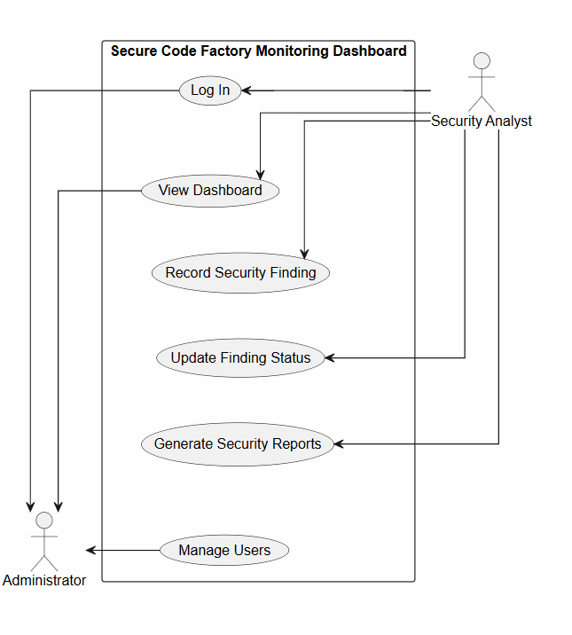

5.2 Class Diagram
The class diagram should represent the main entities and their relationships in the proposed system. The design may include User, SecurityFinding, SDLCComponent, Dashboard, Report and AuditLog. A user may record multiple findings, and each finding should be associated with an SDLC component. The dashboard and reports summarize finding data, while the audit log records important actions. Ensure this explanation matches the actual diagram.
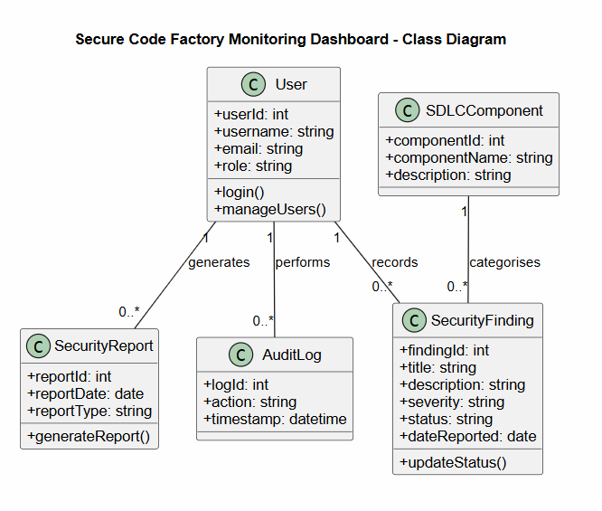

References
Berkovich, S. (2026, March 20). Securing the code factory: Why SDLC infrastructure has become a core cloud risk. SD Times. https://sdtimes.com/security/securing-the-code-factory-why-sdlc-infrastructure-has-become-a-core-cloud-risk/
Django. (n.d.). Getting started with Django. LearnDjango. https://learndjango.com/tutorials/getting-started-django-tutorial
GitHub. (2026, March 2). GitHub for beginners: Getting started with GitHub Issues and Projects. https://github.blog/developer-skills/github/github-for-beginners-getting-started-with-github-issues-and-projects/
MindInventory. (n.d.). Lean software development. https://www.mindinventory.com/blog/lean-software-development/
Wiz. (n.d.). SDLC Infrastructure Threat Framework (SITF). https://wiz-sec-public.github.io/SITF/

